****

**Community Wildfire Protection Plan (CWPP) Template (***Rev. 12-17-12***)**

|  |
| --- |
| Note: Following is boilerplate language that can be used in the development of all CWPPs. You only need to fill in your subdivision, HOA, fire protection district or county name.  **Healthy Forests Restoration Act – Guidance and Requirements**  The \_\_\_\_\_\_\_\_\_\_\_\_\_\_\_ Community Wildfire Protection Plan (CWPP) has been developed in response to the Healthy Forests Restoration Act of 2003 (HFRA). This legislation established unprecedented incentives for communities to develop comprehensive wildfire protection plans in a collaborative, inclusive process. Furthermore, this legislation directs the Departments of Interior and Agriculture to address local community priorities in fuels reduction treatments on both federal and non-federal lands.  The HFRA emphasizes the need for federal agencies to collaborate with communities in developing hazardous fuels reduction projects, and places priority on treatment areas identified by communities through development of a CWPP. Priority areas include the wildland-urban interface (WUI), municipal watersheds and other local values at risk, areas impacted by windthrow or insect or disease epidemics, and critical wildlife habitat that would be negatively impacted by a catastrophic wildfire. In compliance with Title 1 of the HFRA, the CWPP requires agreement among local government, local fire departments and the state agency responsible for forest management (the Colorado State Forest Service). The CWPP also must be developed in consultation with interested parties and the applicable federal agency managing lands surrounding at-risk communities.  **Colorado’s Minimum Standards for CWPPs**  The HFRA also required the Colorado State Forest Service (CSFS) to establish minimum standards for development of CWPPs in Colorado, and the CSFS must approve any and all CWPPs to ensure that they meet these minimum standards. Please see Colorado’s Minimum Standards for CWPPs at <http://csfs.colostate.edu/pdfs/FINAL_Revised_CWPP_Minimum_Standards_111309.pdf>  Electronic files of approved CWPPs, in addition to educational and reference materials, can be found on the CSFS website at <http://csfs.colostate.edu/pages/community-wf-protection-planning.html>.  If your county has a CWPP, and you are developing a subdivision, homeowners association (HOA), fire protection district (FPD) or other CWPP that references the county plan, you might want to add the following statement:  This \_\_\_\_\_\_\_\_ Community Wildfire Protection Plan tiers the \_\_\_\_\_\_\_\_\_\_ County CWPP approved in \_\_\_\_\_\_\_ (date). This plan is consistent with the goals and strategies described in the \_\_\_\_\_\_\_\_ County CWPP, and provides further strategic and tactical direction specific to wildfire protection and mitigation for the \_\_\_\_\_\_\_\_ community.  If desired, your county Annual Operating Plan (AOP) information can be inserted here. Contact your local sheriff’s department for the AOP. |

|  |  |
| --- | --- |
| Please enter your responses in the shaded areas below. Much of the information and many maps can be copied and pasted or inserted from your Colorado Risk Assessment Portal (CO-WRAP) Risk Assessment Summary Report.  \*Information *sources include: 1-US Forest Service (USFS)/Bureau of Land Management (BLM), 2-Colorado State Forest Service, 3-Local Fire Department, 4-Local County, 5-CO-WRAP, 6-Colorado Division of Fire Prevention and Control* | |
| **The Planning Process** | |
|  | *Instructions/Participation Process: Assemble a small working group of knowledgeable people, including property owners, CSFS and local government representatives, and the local fire chief. Briefly describe the public activities that will occur in the development of your CWPP, including how the leadership will reach out to the community and how participants will work together to contribute to the CWPP. Community and stakeholder participation is required.* |
| **1.** | How have you collaborated to develop your CWPP? |
|  |  |
| **2.** | Who did the core planning or leadership group involve? |
|  |  |
| **3.** | Describe the meetings you held (who attended, number of meetings, what you did) |
|  |  |
| **Description of Partners and Committees** | |
|  | *Instructions/Participation Process: List the working group members from the community, fire department/FPD and any other agencies that are providing information or assistance in development of the CWPP.* |
| **1.** | Name the members of the core planning team and what organization or agency they represent. If appropriate, describe the chairperson or key contact, as well as any smaller working groups. |
|  |  |
| **Background and History** | |
|  | *Instructions/Participation Process: Using your core planning team, provide relevant information for the following.* |
| **1.** | Name, location, township and range, and general elevation of the local community. |
|  |  |
| **2.** | Number of wildfires that have occurred within or near your community in the past 20 years. Percentage of lightning vs. human-caused Fires. \*5,1,3,2,6 |
|  |  |
| **3.** | Describe the characteristics (size, cause, severity) of the wildfires and their impact (evacuations, structures lost or threatened) on the community and surrounding forest. \*1,3,2 |
|  |  |
| **4.** | Describe what the community has been doing to be more prepared for a wildfire. List the wildfire mitigation activities that property owners and others have been doing to reduce the impacts of a wildfire. |
|  |  |

|  |  |
| --- | --- |
| **The CWPP Area** | |
|  | *Instructions/Participation Process: Using the same core planning team, perhaps expanded by 2-3 members (USFS, BLM, Colorado Parks and Wildlife or tribal), begin to draw a map of the CWPP area showing the external boundaries, ownership types, and fire protection coverage and gaps. Completing this section addresses the WUI description. You must, at a minimum, include the WUI boundary map in your CWPP.* |
| **1.** | Describe the WUI area that the CWPP will cover. \*5,2,1 |
|  |  |
| **2.** | Identify its boundaries. \*5, 2,1 |
|  |  |
| **3.** | Describe the amount (acres/percent) and characteristics of the **private** land within the WUI. \*5,4,2,1 |
|  |  |
| **4.** | Describe the amount (acres/percent) and characteristics of the **public** land within the WUI. \*5,4,2,1 |
|  |  |
| **5.** | Describe the type of fire protection for the area (fire protection district, federal land management agency, or county sheriff). \*3,2,1 |
|  |  |
| **Fire Policies and Programs** | |
|  | *Instructions/Participation Process: Assign a small group to determine whether local standards or procedures exist at the county or HOA level that will affect the plan. List all relevant policies.* |
| **1.** | Determine what federal, state and local policies and plans will govern the CWPP. These range from the Healthy Forest Restoration Act to local HOA covenants and standards. |
| **Description of the Community** | |
|  | *Instructions/Participation Process: Appoint a subgroup to write a description of the community. Use a map as needed. Prepare a general profile of the characteristics that define the community (describe how it is growing or changing, its natural and land-use characteristics, economic considerations or issues, and its general social composition – for example, percentage of seasonal or year-round residents, renters vs. owners, etc.)* |
| **1.** | List some of the characteristics of the community.  \*Its natural environment -- trees, water, wildlife. \*1, 2,5 |
|  |  |
| **2.** | \*Total population, number of homes, vacant lots and how fast it is growing. \*4 |
|  |  |
| **3.** | \*Road system and linkages (access, adjacent properties). \*4,3,2,1 |
|  |  |
| **4.** | \*Land uses – residential, commercial, recreational and other types. \*4,3 |
|  |  |

|  |  |
| --- | --- |
| **Wildfire Risk Assessment** | |
|  | *Instructions/Participation Process: Numerous factors determine whether the risk of a wildfire is high, moderate or low for any given community. Using the core planning team, with additional assistance from the CSFS, begin to examine the various risk factors for your CWPP area. Some of these factors can more easily be described by community residents, while others will require more technical advice from forestry or fire management personnel.* |
| **1.** | **Fire Hazard** (Vegetation, slope) – provide a description of community fire conditions: \*5,1,2,3,6   * Vegetation type and density, and natural fire regime. |
|  |  |
|  | * History of fire occurrences. |
|  |  |
|  | * Overall topography (shape of the ground, aspect). |
|  |  |
|  | * Seasonal weather patterns affecting fire behavior. |
|  |  |
| **2.** | **Structural Vulnerability:** \*3,2,1   * Structural Ignitability (roof type, siding, decks, landscaping). |
|  |  |
|  | * Access to structures by firefighting equipment (driveway width, overhanging vegetation). |
|  |  |
|  | * Approximate percentage of structures with fire mitigation treatments. |
|  |  |
| **3.** | **Protection Capabilities:** \*3,2,1   * Description of road system accessibility (one-lane roads, turnarounds). |
|  |  |
|  | * Availability of fire hydrants/water storage. |
|  |  |
|  | * Internal community fire protection capabilities (equipment, trained volunteers). |
|  |  |
| **4.** | **Fire Risk** (occurrence/ignition type) \*5,3,1,2   * General risk level: high, moderate, low. |
|  |  |
|  | * Potential(s) for lightning-caused fires. |
|  |  |
|  | * Potential(s) for human-caused fires. |
|  |  |
| **5.** | **Values at Risk:** \*5,4,3,1,2   * Number of lives at risk. |
|  |  |
|  | * Numbers and density of residences. |
|  |  |
|  | * Other economic values – additional structures and facilities, watersheds and municipal water supplies. |
|  |  |
|  | * Ecological values – biological diversity, habitat, threatened and endangered (T&E) species, endemic species, soil, air, water quality and ecosystem health |
|  |  |
|  | * Social values – views, pets, livestock, livelihood, cultural, recreational and historic resources. |
|  |  |
| **Emergency Management** | |
|  | *Instructions/Participation Process: Can the neighborhood or HOA CWPP reference the following items in the county wildfire protection plan? If not, please refer to the local fire authority on your core planning team.* |
| **1.** | **Protection Capabilities & Infrastructure Protection** \*3,4,2,1,6   * Fire Protection District capabilities (average response time). |
|  |  |
|  | * Inventory of fire protection resources. |
|  |  |
|  | * Local wildland fire management policies (full suppression, partial suppression, etc.). |
|  |  |
|  | * Training resources and needs. |
|  |  |
|  | * Mutual aid agreements. |
|  |  |
|  | * Evacuation Information: telephone trees, emergency contacts, address identification, community information database. |
|  |  |

|  |  |
| --- | --- |
| **Mitigation and Implementation Plan** | |
|  | *Instructions/Participation Process: Use the following items to construct an action plan in – outreach, fuels reduction and policy. As a next step, it might be helpful to organize the information in a matrix.* |
| **1.** | **Education and Community Outreach:** \*3,2,1  Describe the audience. |
|  |  |
|  | Describe outreach methods (e.g., meetings, surveys, work days, various media, flyers, etc.). |
|  |  |
|  | Describe any current wildfire prevention and/or education activities. |
|  |  |
|  | Describe specific outreach actions that will increase community awareness and mitigation actions. |
|  |  |
|  | Resources needed – describe educational costs and volunteer efforts. |
|  |  |
| **2.** | **Fuels Reduction**: \*2,1,3,5  Discuss strategies for hazardous fuels treatments and methods to be used. Include approximate timelines for these activities. |
|  |  |
|  | List community partners and describe what, when and where they are doing fuels treatments. |
|  |  |
|  | Identify current or past fuels reduction projects. |
|  |  |
|  | Using the strategies described above, describe high-priority future projects: location, size, purpose, prescription of fuels treatments, disposal plan for wood residue (trees, branches and other excess woody debris), and estimate of project costs and resources needed. |
|  |  |
| **3.** | **Policies or Covenants:** \*4,3,2,1  Describe existing authorities that govern land uses and fuels management activities. |
|  |  |
|  | What additional policies are desired or needed to reduce wildfire risk (land use codes, municipal policies)? |
|  |  |
|  | If resources are needed and can be concretely described, inventory them here. |
|  |  |

|  |  |
| --- | --- |
| **Monitoring and Evaluation** | |
|  | *Instructions/Participation Process: How will multiple stakeholders be involved? Describe the key indicators for successful implementation or improvement. Set times for annual updates to the implementation plan. The entire CWPP should be updated a minimum of every five years. How will community leaders and residents remain involved? State how lessons learned and accomplishment of benchmarks will be used to improve the plan.* |
| **1.** | **Monitoring** \*1,2   * List multi-party (diverse stakeholder) monitoring (who and what). |
|  |  |
|  | * Describe benchmarks/objectives and how they are being met. |
|  |  |
|  | * Develop an annual update of progress. |
|  |  |
|  | * Develop a plan for updating and keeping the community and community involved. |
|  |  |
| **2.** | **Evaluation** \*1, 2, 3   * Describe lessons learned. |
|  |  |
|  | * Measure progress using benchmarks and indicators (include acres of fuels reduction accomplished annually). |
|  |  |
|  | * Revise and update the CWPP with new information and identified needs. |
|  |  |

|  |  |
| --- | --- |
| **\*\*Optional\*\* NFPA Firewise Communities/USA® Recognition Program** | |
| *Instructions/Participation Process: The National Fire Protection Association (NFPA)* ***Firewise Communities/USA Recognition Program*** *provides resources and action steps homeowners can take now to reduce their community’s risk of wildfire damage in the future. After completing a CWPP, your community may realize that it already has completed the requirements for the NFPA Firewise Communities/USA Recognition Program, and the only remaining step is to complete an application.*  *Following are the benefits of receiving NFPA Firewise Communities/USA recognition:*   * *Provides community-building opportunities that will enhance your CWPP and reduce wildfire risk* * *Fosters a sense of pride throughout the community* * *Promotes visibility for the community by providing metal signs, a plaque and other materials that recognize the community as a NFPA Firewise Communities/USA designee* * *Improves the chances of receiving grant funding* * *Focuses resident action on homes and their immediate surroundings to reduce structural ignitability*   *For more information on the benefits and requirements of the Firewise Communities/USA Recognition Program, please visit* [*www.firewise.org*](http://www.firewise.org)*.* |
| **Requirements**   * Obtain a [wildfire risk assessment](http://www.firewise.org/communities/usa-recognition-program/program-criteria/more-about-the-wildfire-risk-assessment.aspx) as a written document from your state forestry agency or fire department. *A completed and approved CWPP meets this requirement.* |
|  |
| * Form a board or committee and [create an action plan](http://www.firewise.org/communities/usa-recognition-program/program-criteria/more-about-your-local-action-plan.aspx) based on the assessment. *The board or committee can include members of the CWPP planning team. The Mitigation and Implementation Plan in the CWPP qualifies as an action plan.* |
|  |
| * Conduct a [“Firewise Day” event](http://www.firewise.org/communities/usa-recognition-program/program-criteria/more-about-the-firewise-day.aspx). *This step may have been included in the CWPP, depending on what type of community engagement was completed. A “Firewise Day” can include a “chipper day” that engages volunteers to chip up brush and limbs, a community clean-up day or workshop. Firewise events can help you get the work done to make your community safer. Keep in mind, to renew the community’s Firewise status, a “Firewise Day” must occur once annually.* |
|  |
| * [Invest](http://www.firewise.org/communities/usa-recognition-program/program-criteria/more-about-your-firewise-investment.aspx) a minimum of $2 per capita annually in local Firewise actions. *Check with the HOA to see if this step is already complete. Work by municipal employees or volunteers using municipal and other equipment can be included, as can state/federal grants dedicated to this purpose.* |
|  |
| * [Submit an application](http://www.firewise.org/communities/usa-recognition-program/program-criteria/apply-for-recognition.aspx) to your local CSFS district forester. *Applications are available online at* [*www.firewise.org*](file:///C:\Documents%20and%20Settings\lmason\My%20Documents\www.firewise.org)*.* |
|  |
| **Renewal**   * Submit a renewal form each year to your local CSFS district forester to maintain the Firewise recognition status. *Renewal forms are available online at* [*www.firewise.org*](http://www.firewise.org)*.* |
|  |

*This CWPP framework was developed by Craig Goodell, San Juan Public Lands; Kent Grant, Colorado State Forest Service; Dr. Sam Burns, Office of Community Services at Fort Lewis College; and Pam Wilson, FireWise of Southwest Colorado, working with information previously developed by Resource Innovations, Institute for a Sustainable Environment, University of Oregon.*

*The Colorado State Forest Service would like to thank them for permission to adapt and use this CWPP template.*

*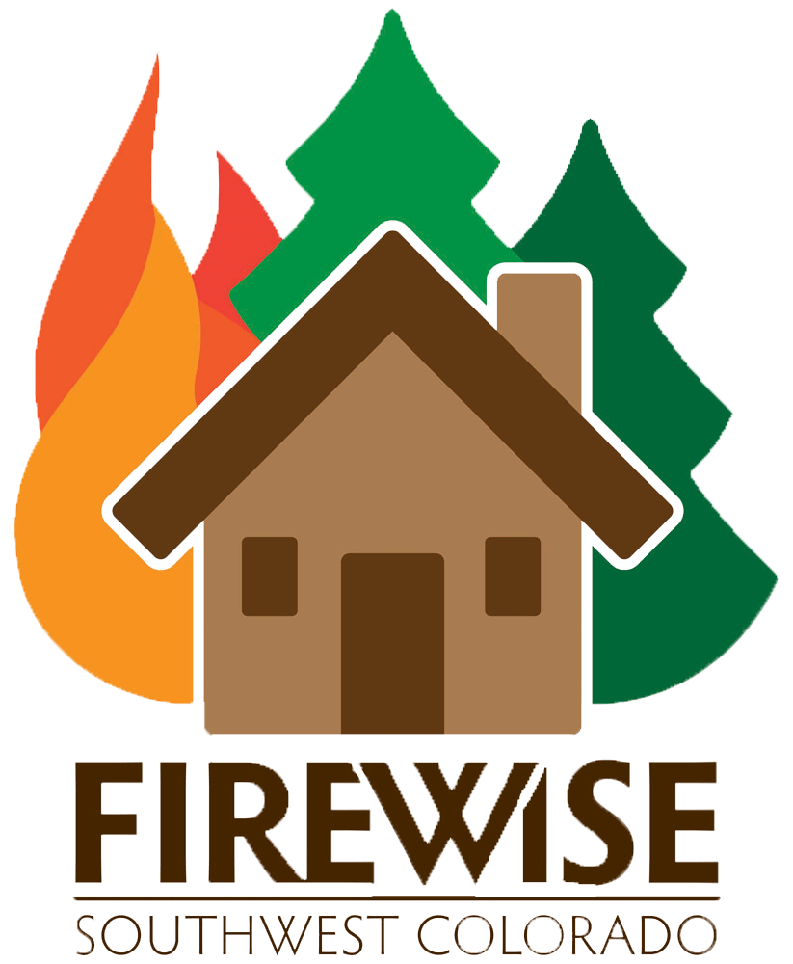 *

*The Colorado State Forest Service, in collaboration with the National Fire Protection Association is working to educate communities across the state on how they can become “fire adapted.” A Fire Adapted Community takes responsibility for its wildfire risk and continues to reduce that risk through planning, education and action. Developing a Community Wildfire Protection Plan and using the Firewise Communities/USA® Recognition Program are two key components that will help your community to become fire adapted. For more information, please visit* [*www.csfs.colostate.edu*](http://www.csfs.colostate.edu)*,* [*www.fireadapted.org*](http://www.fireadapted.org) *and* [*www.firewise.org*](http://www.firewise.org)*.*

*4_FirewiseLogoColor_NFPA_process_CS3.eps 